**Shelton Parks & Recreation**



Shelton Community Center

41 Church Street, Shelton, CT 06484

Info/Cancellation: 🕿 203.331.4120

Main Office: 🕿 203.925.8422

[**www.sheltonparksandrec.org**](http://www.sheltonparksandrec.org)

**PROGRAMS- Children**

**Fall 2019**

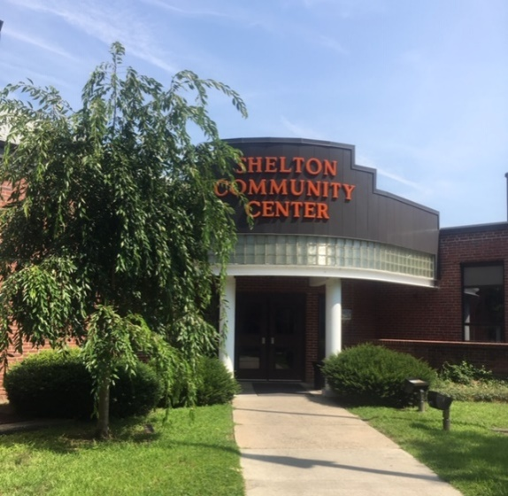

For up to date information visit [**www.sheltonparksandrec.org**](http://www.sheltonparksandrec.org)

Follow us on Facebook for up to date information on events,

programs, leagues, and activities.

**Office Hours**

Monday – Friday: 6:30 am – 9:30 pm

Saturday: 7:30 am – 3:30 pm

j0331453

**Inclement weather**: Call the Information/Cancellation Line 🕿**203.331.4120**

**Registration**

* Register for programs at the Community Center main office unless stated otherwise.
* Registration cannot be completed without cash or check payment.

**Cancellations**

* Programs may be cancelled at any time due to low enrollment.
* You will be notified and given a full refund for the program.
* In the event that an instructor has to cancel an individual class, you will be notified and the class will be made up at the end of the session.

Parks & Recreation Director: Ron Herrick,[**r.herrick@cityofshelton.org**](mailto:r.herrick@cityofshelton.org)

Recreation Supervisor: Bill Manion, [**b.manion@cityofshelton.org**](mailto:b.manion@cityofshelton.org)

**Shelton Parks & Recreation**



[www.Sheltonparksandrec.org](http://www.Sheltonparksandrec.org)

**Child Program Descriptions**

**Program Schedule Follows**

**Register at Community Center main office unless stated otherwise.**

**BringtheHoopla: Girl Power***: Ages 7-13*

This is a 6-week program where girls ages 7 thru 13 will discover and develop their strengths, surround themselves with positive peers and dive into their creativity through play, art and exercise. Through (hula) hooping, and active and healthy themes, we offer a girls-only, safe and welcoming environment that fosters mutual respect and support. Girls will focus on creativity, confidence, leadership, mutual respect, communication, self-esteem all through our hand-made hoops as the main tool.  No hoop experience is necessary.

Nicole Mikula, head of Bring the Hoopla. [**www.bringthehoopla.com**](http://www.bringthehoopla.com)

**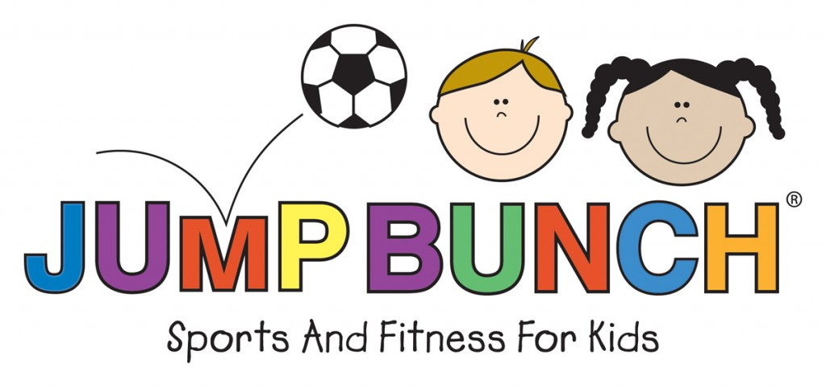**

**JumpBunch:***Age 2 with caregiver, Ages 3-5, Happy Day Preschool Ages 3-5*

Each week, JumpBunch Coaches teach lively, energetic classes that offer an opportunity for children to develop sports skills such as throwing, kicking, balance, agility, and coordination. All of this is done through a variety of fun, non-competitive activities. Upbeat music coupled with a different sport each week assures that children are actively engaged and excited for each class.

Instructor: JumpBunch Coach, [**www.jumpbunch.com**](http://www.jumpbunch.com)

**Kids Pottery**: *Ages 9 & older.*

Children will learn how to make pottery on a pottery wheel. Numerous projects will be made including mugs, ice cream bowls, vases, pitchers and plates. The children will also learn how to hand build by making coil bowls and mugs. All glazes are nontoxic, once fired everything can be used at home!

Instructor: Hope Harvey

**Lil’ Dragons Karate:***Ages 3-5*

Program is designed to teach basic karate skills to preschool age children

Student progress by mastering skills that focus on behavioral, motor, and technical skills. Positive reinforcement teaches students focus, discipline, self-control, and respect in a fun and energizing way.

\*New students-$30 for uniform to instructor.

Instructor: Sarah Bergers, 2nd Degree Black Belt & certified Kinder Kicks Instructor.

**Music & Movement**:*Ages 1-5 with caregiver*

[](http://lynnlewisandfriends.com/)Features parachute time, puppets, musical instruments, and songs to sing along with and dance to. Costume character appearances.

Instructor: Lynn Lewis, Entertainment Express owner.

EN00307_**Tap & Ballet Dance:***Ages 3-4*

Introduction to various dance techniques and allow children to express themselves through creative movement. Dancers increase flexibility, coordination, and strength as well as improve balance, posture, grace, and rhythm. Children discover an appreciation of music while improving self-control, group cooperation, self-confidence and respect. The final class is a showcase for the dancers to perform in front of family and friends.

Instructor: Julie Arcos, certified teacher of Dance Educators of America & Kicks Dance Center co-director

**Tumbletrain Gymnastics:***Ages 18 mo-2 yrs. with caregiver*

****Children move at their own pace in this introduction to gymnastics. With open gym time, the students can explore all of the colorful equipment such as tunnels, hoops, mats, balance beams, and more. A variety of props are used to develop fine motor skills, balance and strength. Caregivers act as a second teacher in class.

Instructor: Fran Delvecchio, owner of Tumbletrain Mobile Gymnastics

**Tumbletrain Gymnastics:** *Ages 2.5-3.5 yrs. with caregiver*

This action-packed gymnastics class begins with a fun warm up. Using music to encourage movement, students develop their motor skills and learn special gymnastics positions and stretches. With the use of age-appropriate gymnastics equipment, students learn basic tumbling, balance, strength, and coordination. Encourage your child to try new things and cheer them on in their attempts.

Instructor: Fran Delvecchio, owner of Tumbletrain Mobile Gymnastics

**Tumbletrain Gymnastics**: *Ages 3.5-5 yrs.*

Children have fun learning tumbling skills and work on balance beams, single bar, trampoline, and more. Classes begin with a fun warm up activity before moving onto the equipment. All of the equipment is specifically created for the preschool age child. Tumble Train offers fun, creative lessons designed to teach balance, strength, coordination, flexibility, and to show that fitness is fun!

Instructor: Fran Delvecchio, owner of Tumbletrain Mobile Gymnastics

**HappyFeet Soccer League:** *Ages 3-5*

[](http://www.happysoccerfeet.com/default.aspx?portalid=8408)The HappyFeet League is an excellent opportunity to watch your little one develop and showcase their HappyFeet soccer skills. Each league game is preceded by a 30-minute HappyFeet class. Each class, the children take on an amazing adventure using their imaginations and develop great gross motor and soccer specific skills along the way. Our league curriculum maximizes the fun and is the perfect way to introduce kids to organized team sports.

Instructor: HappyFeet Coaches.

**REGISTER ONLINE:** [**www.happyfeetct.com**](http://www.happyfeetct.com)

**Squirts Multi Sports**: *Ages 3-5 with Caregiver*

Program allows children to experience a variety of sports throughout the program. It is the perfect introduction to athletics for your future sports star! Each session begins with a brief introduction to the day's sport and equipment before jumping into the first skill-acquisition activity. In addition to emphasizing the fundamentals of each sport, each activity is designed to improve hand-eye coordination, balance, agility and movement.  Each session finishes with an exciting game-related activity or scrimmage.  All sports are taught in a safe, structured and fun learning environment designed to ensure learning and most importantly: fun, fun, fun!

Participants will have the opportunity to try Lacrosse, Soccer, T-Ball, & Track & Field. \*

**REGISTER ONLINE:** [**www.ussportsinstitute.com**](http://www.ussportsinstitute.com)

​

**Senior Squirts Sports**: *Ages 5-7 with Caregiver*

An introductory level program, this class is the perfect stepping stone for children who have graduated from the Squirts Multi Sports program or for children looking for their first ever sports experience. Players will learn key skills through small-sided scrimmages in a variety of sports, including Lacrosse, Soccer, T-Ball, and Track & Field\*.

Each session begins with a brief introduction to the day's sport and equipment before jumping into the first skill-acquisition activity. In addition to learning the fundamentals of each sport, each activity is designed to improve hand-eye coordination, balance, agility and movement. Each session finishes with an exciting game-related activity.  All Senior Squirts curricula create an environment which allows players to develop and progress within sport.

**REGISTER ONLINE:** [**www.ussportsinstitute.com**](http://www.ussportsinstitute.com)

**WaterBotics®!**

Different from many land-based robotics programs, WaterBotics® is an innovative, underwater robotic program where teams collaborate to design, build, program, test and redesign underwater robots, made with LEGO® and other components.

Teams use LEGO® materials that are familiar, have ease of use and durability, come in a variety of pieces, and are tweak friendly. Teams will learn about the Engineering Design Process (EDP); a format that engineers use to make life easier by creating and improving how things work.

Teams will learn the 5 steps of The Engineering Design Process (EDP)

1. Identify the Problem

2. Research and Brainstorm

3. Design and Build

4. Test and Evaluate

5. Redesign

To ensure that students do not become daunted by building a complex robot right from the start, the curriculum is divided into a series of four “bite-sized” missions that gradually lead to the production of a fully functional robot. Each mission is a rescue scenario which builds upon the previous one so that designing and building are constantly happening.

**Junior Engineer** (Sessions A & B)

Apprentice

Session A - Mission 1: Rescue! Use a single motor to build a robot that can travel in a straight line—both forward and backward—on the surface of the water and save a drowning swimmer. Optimize gearing to improve speed and/or control.

**(Pre-requisite: completion Session A)**

Session B - Mission 2: Cleanup! Use a second motor to enable steering and two-dimensional movement. Maneuver the robot on the surface of the water to clean up a spill of hazardous pollutants.

**Senior Engineer**(SessionsC&D)

Intermediate

**(Pre-requisite: completion Sessions A & B)**

Session C - Mission 3: Sweep! Use a third motor to dive under the water. Combine high-density and low-density materials to achieve good buoyancy and stability, making the robot controllable underwater. Detonate or disable underwater “mines” to make a shipping lane safe.

**(Pre-requisite: completion Sessions A - C)**

Session D - Mission 4: Collect! Combine the products of previous missions to produce a vehicle that can collect samples from a sunken ship and deposit them in various underwater collection bins. A fourth motor may be used to create a mechanism to grab and release the balls.

**Head Engineer**

Independent Explorers

**(Pre-requisite: completion Sessions A -D)**

Independent Exploration! With the purchase of the WaterBotics® ROV Kit, students design and build robots independently.

***Optional purchase of WaterBotics® ROV Kits available the first day Session D. One WaterBotics® ROV Kit per registrant.***

This is a fun instructional program that directly exposes kids to science and engineering standards required in most school systems that can take 180 days of a school year of textbooks, papers, and tests. WaterBotics® is a proven outlet that helps support the learning of standards by teaching and incorporating science and engineering in a way that is unique, hands-on and most of all fun.

For more information visit our website at [s3stem.com](https://www.s3stem.com/).

Instructors: Leslie Davis-Green/Lee Green/1 Junior Instructor

Leslie Davis-Green, has over 12 years of teaching in the public and private sector. She has a MS in Elementary Education from the University of Bridgeport. She is certified and licensed in WaterBotics® from the Stevens Institute of Technology in Hoboken, NJ conducted by the Center for Innovation in Engineering and Science Education (CIESE) in June 2017.

Lee Green has over 30 years of corporate financial analytical operation experience. He has a M.Ed. in Education Psychology/Instructional Learning Technology from Temple University. He is certified and licensed in WaterBotics® from the Stevens Institute of Technology in Hoboken, NJ conducted by the Center for Innovation in Engineering and Science Education (CIESE) in June 2017.

Other Information

Each day your child will need to bring **light snack with a drink.**

Call Leslie or Lee for curriculum questions (203) 556-1526 or (203) 218-0609.

For more information, contact Bill Manion at [b.manion@cityofshelton.org](mailto:b.manion@cityofshelton.org) **or** (203) 925-8422.

**REGISTER ONLINE:**

**October 2**: <https://www.eventbrite.com/e/waterbotics-stem-programs-shelton-community-ctr-wednesdays-6pm-8pm-tickets-66748702165?aff=affiliate1>

**October 30**: <https://www.eventbrite.com/e/waterbotics-stem-programs-shelton-community-ctr-wednesdays-6pm-8pm-tickets-69001767143?aff=affiliate1>

**December 4**: <https://www.eventbrite.com/e/waterbotics-stem-programs-shelton-community-ctr-wednesdays-6pm-8pm-tickets-69021678699?aff=affiliate1>

***Website***



**www.sheltonparksandrec.org**

 **Shelton Parks & Recreation,** [**www.sheltonparksandrec.org**](http://www.sheltonparksandrec.org)**Fall**



**Children’sFall 2019 Schedule**

**Register with cash or check in Community Center main office or online.**

|  |  |  |  |  |  |  |
| --- | --- | --- | --- | --- | --- | --- |
| **Program** | **Age** | **Days** | **Time** | **Starts** | **Weeks** | **Price** |
| **Jump Bunch** | 2 w/caregiver | Monday | 9:45-10:30 am | **Sep 16** | 6 | $50 |
| Happy Day Preschool  3-5 | Monday | 10:30-11:15 am | **Sep 16** | 6 | $50 |
| 3-5 | Monday | 11:15-12:00 | **Sep 16** | 6 | $50 |
| 3-5 | Tuesday | 11:00-11:45 | **Sep 17** | 6 | $50 |
| **Kids Pottery**  Open Registration Sep 15 | 9-16 | Saturday | 10:00-12:00 | **Oct 5** | 8 | $80 + $20 |
| **Lil’ Dragons Karate** | 3-5 | Wednesday | 11:00-11:30 am | **Sep 25** | 8 | $60 |
| **Music & Movement** | 1-5 | Wednesday | 10:00-10:45 am | **Sep 11**  **Oct 30** | 6 | $65 |
| **Tap and Ballet** | 2.5-3 | Thursday | 9:30-10:15 | **Sep 19**  **Oct 31** | 6 | $45 |
| 4-5 | Thursday | 10:15-11:00 | **Sep 19**  **Oct 31** | 6 | $55 |
| **Tumbletrain** | 18 mos-2 yrs. w/caregiver | Friday | 10:00-10:30 am | **Sep 20** | 6*or*  12 | $45  $90 |
| 2.5-3.5 w/caregiver | Friday | 10:35-11:05 am | **Sep 20** | 6*or*  12 | $45  $90 |
| 3.5-5 | Friday | 12:20-12:50 pm | **Sep 20** | 6*or*  12 | $45  $90 |
| Happy Day Preschool  2.5-3.5 | Friday | 11:10-11:40 am | **Sep 20** | 6*or*  12 | $45  $90 |
| Happy Day Preschool  3.5-5 | Friday | 11:45-12:15 | **Sep 20** | 6*or*  12 | $45  $90 |
| **Online Registration Only** | | | | | | |
| **HappyFeet Soccer**  [**www.Happyfeetct.com**](http://www.Happyfeetct.com) | 3-5 | Sunday | 9:30-10:30 am | **Sep 15** | 8 | $105 |
| **Squirts Multi Sports**  **With Caregiver**  [**www.ussportsinstitute.com**](http://www.ussportsinstitute.com) | 2-3 | Sunday | 1:00-2:00 | **Sep 22** | 7 | $134 |
| 3-5 | Sunday | 2:00-3:00 | **Sep 22** | 7 | $134 |
| 2-3 | Saturday | 9:00-10:00 | **Sep 21** | 7 | $134 |
| 3-5 | Saturday | 10:00-11:00 | **Sep 21** | 7 | $134 |
| 5-7 | Saturday | 11:00-12:00 | **Sep 21** | 7 | $134 |
| **Happy Hoopin-Girl Power**  [www.bringthehoopla.com](http://www.bringthehoopla.com) | 5-16 | Monday | 6:30-7:30 | **Sep 16** | 6 | $65 |
| **WaterBotics®**  Web site link in  description page above | 10-14 | Wednesday | 6:00-8:00 | **Oct 2**  **Oct 30**  **Dec 4** | 4 | $140 |